Case 5-Asia-China-Yangshao Culture-Pan shan Phase (平山)-Mortuary Amphora-Terracotta-2750-2250 BCE

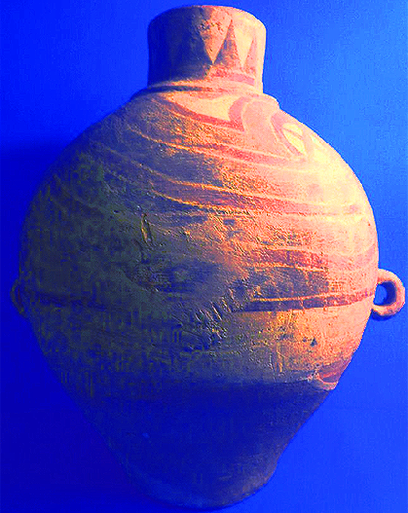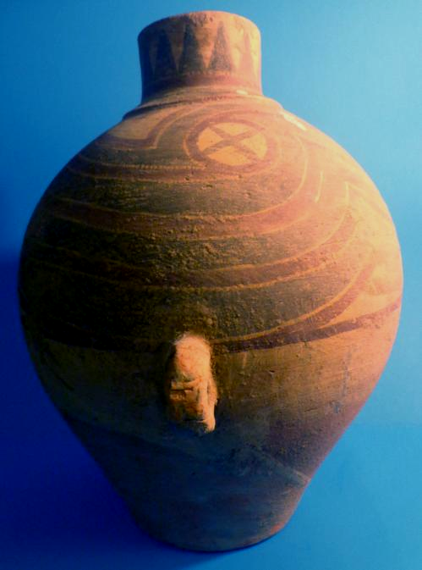

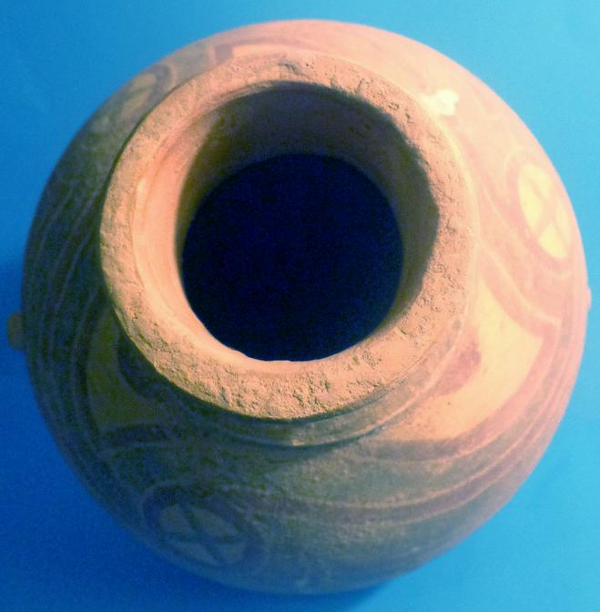 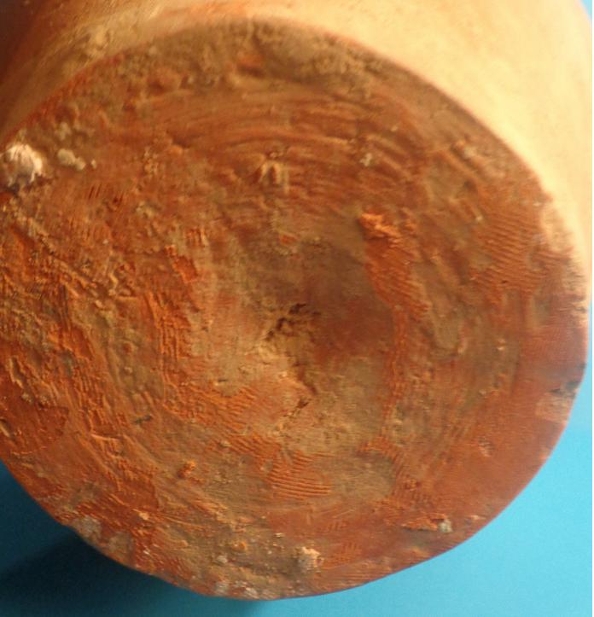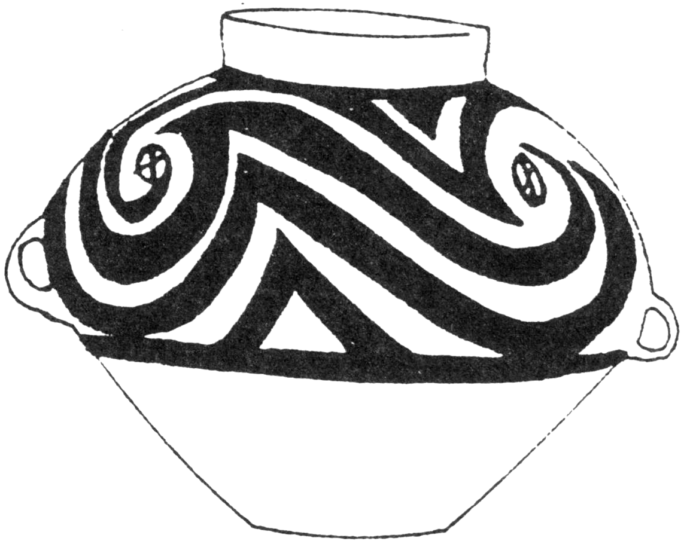

Figs. 1-5. China-Yangshao Culture-Pan shan Phase (平山)-Mortuary Amphora-Terracotta-2750-2250 BCE. Figs. 1-4 present example, showing a combination of interlocking curved lines (goulianwen 勾 连 纹), circles enclosing crosses and a straight lip, narrow mouth. Fig. 5, showing the same combination of interlocking curved lines (goulianwen 勾 连 纹), circles enclosing crosses and a straight lip, narrow mouth, from *Kaogu* 1962, no. 6, p. 323.

Case no.: 5

Accession Number:

Formal Label: China-Yangshao Culture-Pan Shan Phase (平山)-Mortuary Amphora-Terracotta-2750-2250 BCE.

**Display Description:**

The Yangshao Culture encompasses a series of riverine sites across N and C China (E Gansu, E Qinghai, Shaanxi, Shanxi, Ningxia, Henan, Hubei) some bordering the Huang-Ho (Yellow River) of the Middle Neolithic Period (5000-2500 BCE). Ritual (as opposed to utilitarian) ceramics from these sites was first formed with coils of clay that were compacted by paddles to strengthen the joints, and then the entire vessel was scraped and smoothed while wet (Palmgren 1934:1-5). The potter's wheel was not used during this period. The clay was fired in a kiln at 900-1000o C (Valenstein 1989:3).

The painting on these Pan Shan Phase (平山) ceramics was probably related to their mortuary context. For instance, red and black are traditionally associated with life-blood and death-interment. The interlocking, curvilinear and cresting motifs suggest flowing water as a source of life in rivers and irrigation canals, since millet agriculture and fish were central to the Yangshao economy. Crosses in circles, recurred throughout the six phases of the Yangshao culture over three millennia and may signify the placement of cemeteries (crosses) within villages (circles) amidst flowing riverine waters (curvilinear motifs), since these amphora were found in mortuary contexts. A pair of loop handles at mid-section produced a suggestive, anthropomorphic, hands-akimbo effect, which would have been quite appropriate for their mortuary use.

**LC Classification:** GN855.C6

Date or Time Horizon: 2750-2250 BCE

Geographical Area: N and C China

**Map:**

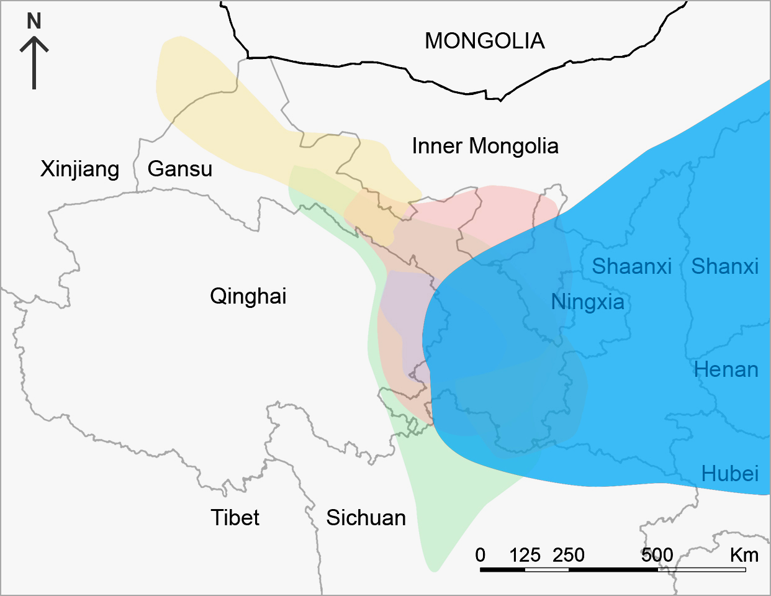 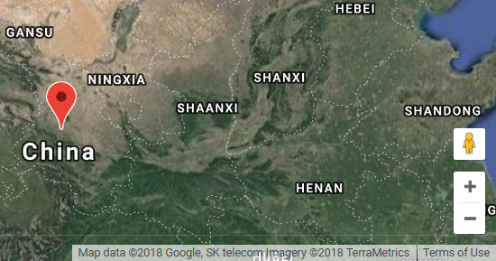

Fig. 6. Partial map of Yangshao Culture (blue) after <https://s3.amazonaws.com/media.harvardartmuseums.org/production/uploaded_files/tour_builder/o_1aj4mlk0qf86jru11dsk65v2v23.jpg?height=675>

Fig. 7. Location of Pan-shan-chü type site in Lin-t’ao: 35° 22' 40" N, 103° 51' 23" E

**GPS coordinates:** Pan-shan-chü type site: 35° 22' 40" N, 103° 51' 23" E

Cultural Affiliation: Yangshao Culture-Pan shan Phase (平山)-2750-2250 BCE.

Media: terracotta, cinnabar (HgS) red pigment, manganese dioxide (MnO2) black pigment

Dimensions: H 11in, W 9 in

Weight:

Condition: some expected wear, degradation, natural crazing, abrasions, and chips as a consequence of extended burial.

Provenance:

**Discussion:**

The Yangshao Culture was the most widely dispersed and longest lasting of all Chinese Neolithic cultures, spanning six phases across seven provinces: Ban-po (5000-4500 BCE), Miao-ti-kou (4500-4000 BCE), Shih-ling-hsia (3750-3250 BCE), Ma-chia-yao (3250-2750 BCE), Pan-shan (2750-2250 BCE), and Ma-ch'ang (2250-1750 BCE).

The Pan-shan (Banshan) Phase of the Yangshao culture overlapped with the Ma-chia-yao in the east of Gansu and extended northward through Lan-Chou to Wu-wei and Yüng-ch'ang. The sites of the Pan-shan phase include the following: Pan-shan-chü in Lin-t'ao, the type site (Palmgren 1934), Ti-pa-p'ing in Kuang-ho (Archaeological Team of the Kansu Provincial Museum. 1978), a series of sites in Lan-chou (Hua-chi-tzu, Ch'ing-kang-ch'a, T'u-ku-t'ai); Chang-chia-t'ai in Ch'ing-t'ai County, Kansu (Kansu Provincial Museum 1976) and Liu-wan in Ch'inghai (Archaeological Team of CPAM 1976, Qinghai Sheng 1984).

Pan-shan pottery was first excavated by Johan Gunnar Andersson in the 1920’s, who added examples to the Museum of Far Eastern Antiquities in Stockholm, and it was first studied by Nils Palmgren (Palmgren 1934). This current vessel was probably acquired during this period.

These burnished, painted wares appear to have been intended primarily for mortuary use, since most have been discovered in tombs. However, some have been unearthed in habitation areas as well, and these may have been produced for family-related ceremonies.

**References:**

Andersson, Johan Gunnar. 1943. *Researches into the prehistory of the Chinese.* Bulletin of the Museum of Far Eastern Antiquities, no. 15. Stockholm: Museum of Far Eastern Antiquities.

Archaeological Team of CPAM, Chinghai Province and the Chinghai Archaeological Team, IAAS. 1976. The Main Issues Posed by the Finds from the Primitive Society Cemetery at Liu-wan in Yueh-tu County, Chinghai Province, *Kaogu*考古, no.06

Archaeological Team of the Kansu Provincial Museum. 1978. “Excavation of a Neolithic Cemetery of the "Pan Shan" Type at Ti-pa-p'ing in Kuang-Ho County, Kansu Province,” *Kaogu Xuebao*考古学报, no.2: 193-209.

Kansu Provincial Museum 1976. “The Neolithic Cemetery at Chang-Chia-t'ai in Ching-t'ai County, Kansu Province,” *Kaogu*考古, no. 3

Palmgren, Nils. 1934. *Kansu mortuary urns of the Pan Shan and Ma Chang groups*. Palaeontologia Sinica. Series D, Volume III, Fascicule 1. Peiping [Beijing]: Geological survey of China and Stockholm: The Museum of Far Eastern Antiquities.

Qinghai Sheng wen wu guan li chu. Kao gu dui. 1984. *Ch'ing-hai Liu-wan*. Added t.p.: *Excavation of a primitive society cemetery at Liuwan in Qinghai, with English abstract*. Beijing: Wen wu ch'u pan she.

Valenstein, Suzanne G. 1989. *A Handbook of Chinese ceramics*. Rev. and enlarged. ed. New York: Metropolitan Museum of Art.

PAINTED POTTERY JAR WITH ZIGZAG PATTERN  
Machang Phase of Majiayao Culture, 2300—2000 B.C.

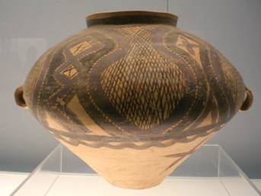

PAINTED POTTERY POT WITH   
GEOMETRIC LATTICE PATTERN  
Banshan Type of Majiayao Culture, 2600—2300 B.C.

**Shilingxia** (Shílǐngxià yízhǐ石岭下遗址Shilingxia site) is a Neolithic site of the [Yangshao culture](http://translate.googleusercontent.com/translate_c?depth=1&hl=en&prev=/search%3Fq%3D%2522shilingxia%2522%26num%3D100%26lr%3D%26newwindow%3D1%26as_qdr%3Dall&rurl=translate.google.ca&sl=de&u=http://de.wikipedia.org/wiki/Yangshao-Kultur&usg=ALkJrhhbEUTLs8EuqVN2DbBd76ONIufALg) and the [culture Majiayao](http://translate.googleusercontent.com/translate_c?depth=1&hl=en&prev=/search%3Fq%3D%2522shilingxia%2522%26num%3D100%26lr%3D%26newwindow%3D1%26as_qdr%3Dall&rurl=translate.google.ca&sl=de&u=http://de.wikipedia.org/wiki/Majiayao-Kultur&usg=ALkJrhgy_Org4yyi9Tfi4BJd3c0kwAp13w) on the upper reaches of the [Huang He](http://translate.googleusercontent.com/translate_c?depth=1&hl=en&prev=/search%3Fq%3D%2522shilingxia%2522%26num%3D100%26lr%3D%26newwindow%3D1%26as_qdr%3Dall&rurl=translate.google.ca&sl=de&u=http://de.wikipedia.org/wiki/Huang_He&usg=ALkJrhjd2jxXRu2rMtjxImiNN3MsAb0wsA) (Yellow River) in China. Created in 1947 in the village **Shilingxia**石岭下村most城关镇Chengguan Town of [Wushan County](http://translate.googleusercontent.com/translate_c?depth=1&hl=en&prev=/search%3Fq%3D%2522shilingxia%2522%26num%3D100%26lr%3D%26newwindow%3D1%26as_qdr%3Dall&rurl=translate.google.ca&sl=de&u=http://de.wikipedia.org/wiki/Wushan_(Tianshui)&usg=ALkJrhheTSkYBKM3L2FnhP8gyErNv-iJ6Q) in the Chinese province of [Gansu](http://translate.googleusercontent.com/translate_c?depth=1&hl=en&prev=/search%3Fq%3D%2522shilingxia%2522%26num%3D100%26lr%3D%26newwindow%3D1%26as_qdr%3Dall&rurl=translate.google.ca&sl=de&u=http://de.wikipedia.org/wiki/Gansu&usg=ALkJrhj9f5jcKI8KwsJ2q5O6otz3N2E3pw) discovered and dated to -3900 to -3200.

